How didi you hear of this vacancy:
(If in publication,please state which one. If from current employee of Prolifee, please state name
Have you previously applied for a post with Prolife?
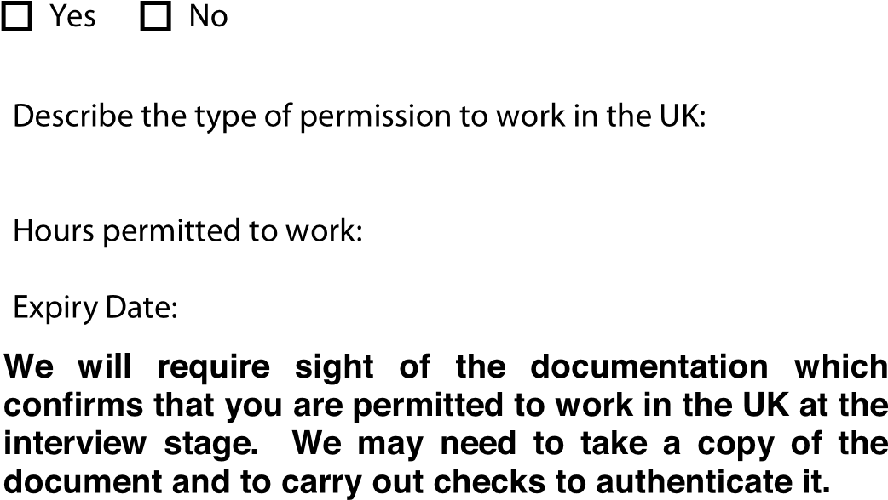

Employment History | Present or most recent employment (paid or unpaid)  This includes any roles prior to moving to the UK (if applicable)
Employer Name, Address including Post Code and Telephone Number | Date(s)  employed | Current/Last Salary | Position(s) Held
Employed

Self Employed
Outline of Duties and Responsibilities:

Reason For Leaving
Please state reason for leaving and confirm current employment status:

Number of Weeks Notice Required

Previous Employment | Please list in chronological order, with your most recent post listed first, including temporary, casual and short term jobs  (Please give your full employment history since leaving school. If you require extra space please attach an additional sheet)
Employer Name, Address including Post Code and Telephone Number | Date(s) employed | Position(s) held and salary | Reason for leaving
Outline of Duties and Responsibilities

Employer Name, Address including Post Code and Telephone Number | Date(s) employed | Position(s) held and salary | Reason for leaving
Outline of Duties and Responsibilities

Employer Name, Address including Post Code and Telephone Number | Date(s) employed | Position(s) held and salary | Reason for leaving
Outline of Duties and Responsibilities

Employer Name, Address including Post Code and Telephone Number | Date(s) employed | Position(s) held and salary | Reason for leaving
Outline of Duties and Responsibilities

Employer Name, Address including Post Code and Telephone Number | Date(s) employed | Position(s) held and salary | Reason for leaving
Outline of Duties and Responsibilities

Employer Name, Address including Post Code and Telephone Number | Date(s) employed | Position(s) held and salary |  | Reason for leaving
Outline of Duties and Responsibilities

Gaps in Employment | Please give details of all periods when not in employment, giving dates and reasons
Dates from: | To: |  | Reason:
Dates from: | To: |  | Reason:
Dates from: | To: |  | Reason:
Dates from: | To: |  | Reason:
Have you ever been dismissed from a previous post or had an employment contract terminated for any reason including redundancy? If so please give details below:
Have you been subject to disciplinary action in your current or any previous posts? (including being the subject of any disciplinary process not yet concluded to resignation) If yes, please give details:
Voluntary Work Experience  Give details of any voluntary or unpaid experience including care of others |  | Language Skills  List all languages spoken fluently and those in which you have a good working knowledge

General Education |  |  | Qualifications Achieved
School/College | From | To | Subject/courses studied, level and grade (eg, GCSE, ‘A’ Level, GNVQ etc)
Further and Higher Education |  |  | Qualifications Achieved
College/University | From | To | Subject/courses studied, level and grade (eg, BA History 2:1)
Professional Training |  |  | Qualifications Achieved
College/University | From | To | Subject/courses studied, level and grade (e.g., BA Social Work/DipSW 2:1)
Professional Membership of Registered Bodies |  |  | Registration No/Renewal Date
Name of Professional Body and Level of Membership | Date |  | Nurses, please give PIN No.  Social Workers please give GSCC Registration No
NVQs and other work related qualifications |  |  | Qualifications Achieved
College/Training Provider | From | To | Awarding body, level and grade if applicable (eg, Edexcel NVQ 4 Pass)
Other vocational and work related training undertaken
List subjects, e.g., First Aid | Duration (e.g., 1 day) |  | Level (if appropriate)

Please tell us why you are applying for this post and why you want to work for Prolife | If in current employment, please explain why you are looking for a new post:
Do you have any restrictions in your working hours or availability?
Please note our requirements in respect of working hours as detailed within the Job Description
Additional Supporting Information | What experience have you gained in your current and previous jobs and general life experience, which you feel would be relevant to the job you are applying for?  Referring to the job description and person specification outline the values, skills, abilities, knowledge and personal qualities you feel you could bring to this post and the agency. Continue on a separate sheet if necessary. If you wish to attach a CV or other information please do so.

References | Please supply the names and addresses of two professional referees who have agreed to provide a reference. It is essential that one of your referees must be your current or most recent employer and that your referee is/was your line manager and not a colleague, relative or friend. Both references cannot be from the same company. References will be verified to ensure authenticity.  Failure to provide the above can result in your application being withdrawn.
Current employer or most recent employer  details | Company
(Business Addresses  Only) | Name
 | Position
 | Address
 |  | Post Code:
 | Tel
 | Fax
 | Email
 | Can this reference be contacted prior to interview Yes / No
Previous employer (if not applicable an academic referee) | Company
(Business Addresses Only) | Name
 | Position
 | Address
 |  | Post Code:
 | Tel
 | Fax
 | Email
 | Can this reference be contacted prior to interview Yes / No
* Unless indicated otherwise all referees will be contacted prior to your invite to individual interview.
YES □ No □
Have you ever been convicted of any criminal offence?

Please note that all positions are subject to an enhanced CRB check. You will be asked to declare all criminal convictions in further details if an offer of employment is made.

DATA PROTECTION ACT
In accordance with the Act, you should be aware that the personal details submitted with this application form will be used only for selection and interview procedures; and for employment records if the application is successful.

DECLARATION
I declare that, to the best of my knowledge and belief, all statements contained in this form are correct and I understand that should I conceal any material fact, I will, if engaged, be liable to the termination of my contract of service with such notice as may be appropriate.

Signature: ____________________________ Date:____________________________
OFFICE USE ONLY
Valuing Diversity
Fairness in Employment Monitoring Sheet – Strictly Confidential
The information on this form will be separated from your application as soon as it is received and it will not be involved in the short-listing or interviewing for the post for which you are applying.

Help us to help you

Prolife is committed to achieving fairness and equality in employment. We want to make sure that all job applicants and employees are treated fairly and are judged solely on their merits and abilities.

What information are we looking for?

We need different kinds of information so that we can check how closely the numbers of people who apply to us for jobs, or who get jobs with us, match up to the local population. This tells us a lot about whether our recruitment processes are fair and equally open to everyone.

Disability - Definition

Under the terms of the Disability Discrimination Act 1995 a person has a disability if she/he has a physical or mental impairment which has a substantial and long-term adverse effect on his/her ability to carry out normal day-to-day activities.
Fairness in Employment Monitoring

My Racial Origin: (please tick appropriate box)
White British Irish European Other

Black or Black Caribbean African
British
Asian or Asian Indian Pakistani Kashmiri Bangladeshi
British
Mixed Race White and White and White and White and
Black Black Indian Pakistani
Caribbean African

Chinese/other group Chinese

For any other racial group please write in box
My gender Female Male

My disability I am not a disabled person I consider myself a disabled
status |  |  | person
If you consider yourself disabled, please detail in your application form so that any adjustments to the selection process may be made (if required)

My age: 16-19 30-39 50-59 65 +

20-29 40-49 60-64

My religion: Christian (including Church of England, Catholic, Protestant and all Jewish other Christian denominations)

Sikh Muslim Hindu Buddhist

None

Any other religion – (please write in the box)

